# PROJECT AND TEAM INFORMATION

## Project Title

**“FileHive – Your Personal File Management Hub”**

Student / Team Information

|  |  |
| --- | --- |
| *Team Name: Team #* | ***HYDRA*** |
| **Team member 1 (Team Lead)** | *Negi, Abhishek – 22011574* [*44.negi@gmail.com*](mailto:44.negi@gmail.com)  [*Abhisheknegi.22011574@gehu.ac.in*](mailto:Abhisheknegi.22011574@gehu.ac.in) |
| **Team member 2** | *Mewar, Aditya – 22011989*  [*adityamewar061@gmail.com*](mailto:adityamewar061@gmail.com) |
| **Team member 3** | *Pal, Arpit – 22011829*  [*arpit.pal.2022@gmail.com*](mailto:arpit.pal.2022@gmail.com) |
| **Team member 4** | *Bisht, Ayush – 220111101*  [*ayushbisht457@gmail.c*](mailto:ayushbisht457@gmail.c)*om* |

# PROPOSAL DESCRIPTION

# Motivation

* Traditional methods of file storage often lead to **disorganization, data redundancy**, and difficulty in accessing information.
* This project aims to create a File Management System that provides a user-friendly interface to organize, store, and **retrieve files effectively**, ensuring better **file categorization**, quick access, and improved productivity.
* What excites us about this project is how it bridges theory and practice. We’ve studied Operating System concepts like **File Management**, Resource Management in class, but now we want to bring them to life by building an integrated solution ourselves. It’s not just about writing code — it’s about understanding how programming languages work at a deeper level.
* Overall, this project is a perfect blend of theory, coding, and creativity — and we’re thrilled to push it forward!

## 

## State of the Art / Current solution

* Currently, file management is handled using various systems such as cloud storage services (Google Drive, Dropbox), local file explorers (Windows File Explorer, macOS Finder), and third-party applications that offer features like file **categorization, sharing, and backup**.
* These solutions provide basic file storage but often lack advanced functionalities like **customized file** categorization, automated file organization, and personalized search options.
* Additionally, most cloud-based solutions require an internet connection and may pose privacy concerns.
* This project aims to overcome these limitations by offering a customized, **offline-capable**, and user-friendly file management system.

## Project Goals and Milestones

* Design a File Management System to efficiently organize, store, and manage files.
* Implement basic file operations like create, read, update, and delete (CRUD).
* Enable file categorization based on file extensions (text files, images, PDFs, etc.). • Provide search functionality to quickly access files by name or type.
* Ensure multi-user support with user-specific directories.
* Demonstrate **file permissions** and **access control** concepts.

## 

## Project Approach (3 pts)

* Requirement Analysis:
* Identify system requirements, including file operations, user authentication, and access control.
* Research existing file management systems to understand their limitations and propose improvements.
* System Design:
  + Design system architecture, including user interface, backend logic, and data storage mechanisms. Create flow diagrams to outline the interaction between users, files, and system components.
* Implementation:
  + Develop core functionalities such as **file creation, deletion, categorization**, and search operations.

## System Architecture (High Level Diagram)

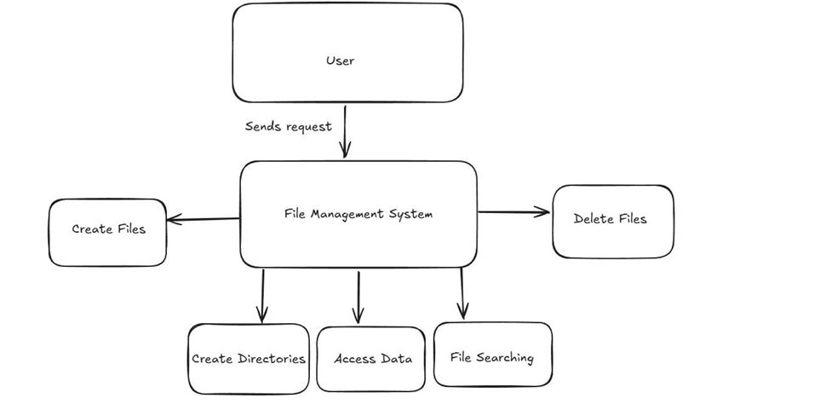

## Project Outcome / Deliverables

* The File Management System aims to deliver an efficient solution for organizing, storing, and managing files while addressing common issues such as disorganization and unauthorized access.
* The expected outcomes of the project are:
* A functional File Management System capable of performing **CRUD operations on files and folders**.
* Enhanced file categorization and search features to improve accessibility
* Improved user experience through a simple and intuitive interface.
* The File Management System aims to deliver an efficient solution for organizing, storing, and managing files while addressing common issues such as disorganization and unauthorized access.
* The expected outcomes of the project are:
  + A fully functional, offline-capable **File Management System** with enhanced search and categorization.

## Assumptions

* The development of the File Management System is based on the following assumptions:
  + The system will handle text files, images, documents, and other common file types.
  + The system will run on local storage without external cloud integration.
  + The file size will be limited to a predefined maximum for performance and storage efficiency.
  + The system assumes basic user knowledge of file operations like creating, deleting, and searching for files.

## References

**Andrew S. Tanenbaum - Modern Operating Systems**

**Operating System Tutorial -** https://www.geeksforgeeks.org/operating-systems/